**MongoDB**

*It **stores data in flexible, JSON-like document.**

**\*It is a distributed database.**

**\*It is a open source.**

**\*It stores data as key value pair.**

**Advantages of MongoDB :-**

* Flexible document schemas(To change the structure of the documents in a collection).
* Code-native data access(Code written in to run in a specific operating system).
* Change-friendly design.
* Powerful querying and analytics.
* Easy horizontal scale-out.

**Different from others:-**

*Basic difference from other is it stored records as well as store objects(JSON like document).

*Using this we don’t need to learn other language to interact with data.

**\*Working of Mongodb:-**

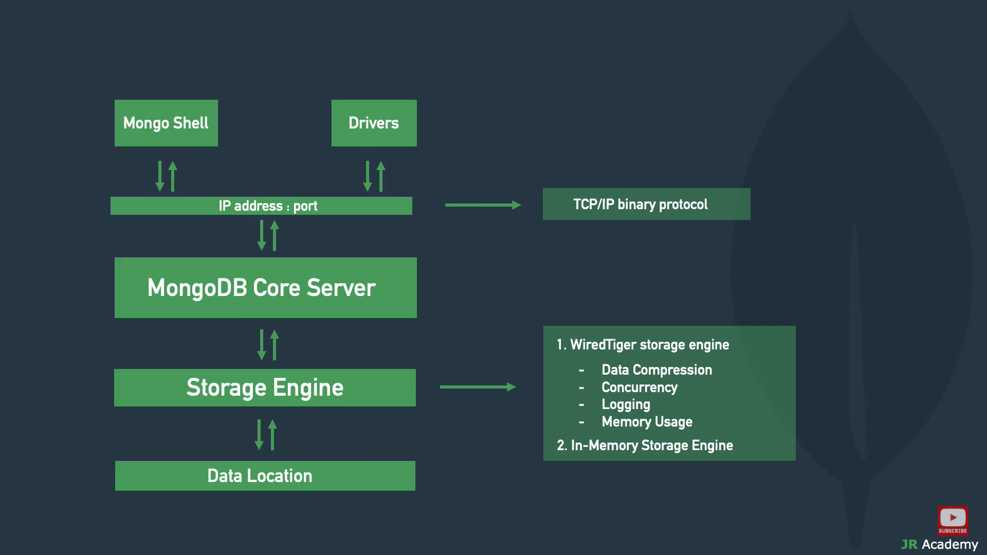

* MongoDb Compass- It is a GUI for mongodb, it communicate servers over network.

**Steps to create Atlas Cluster:-**

1. Create Cluster
2. Setup Network Access
3. Setup Database Access
4. Connect to local system

After these we can test them:

(i)show db- to show all database which are they have.

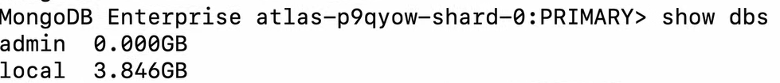

(ii) we can make database and make a collections

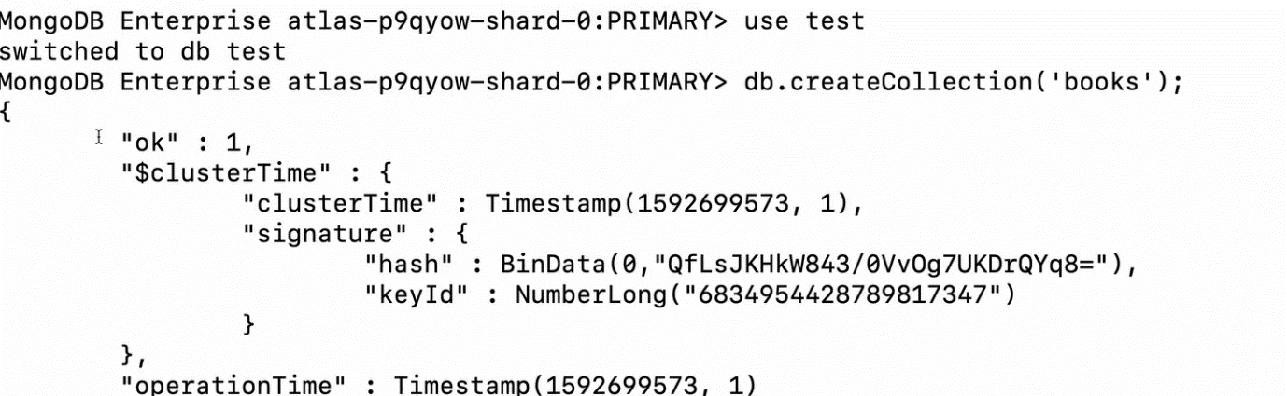

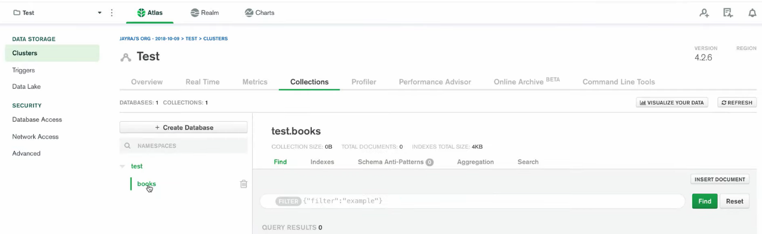

(iii)Than we add documents on them





Note:It shows the document has been added

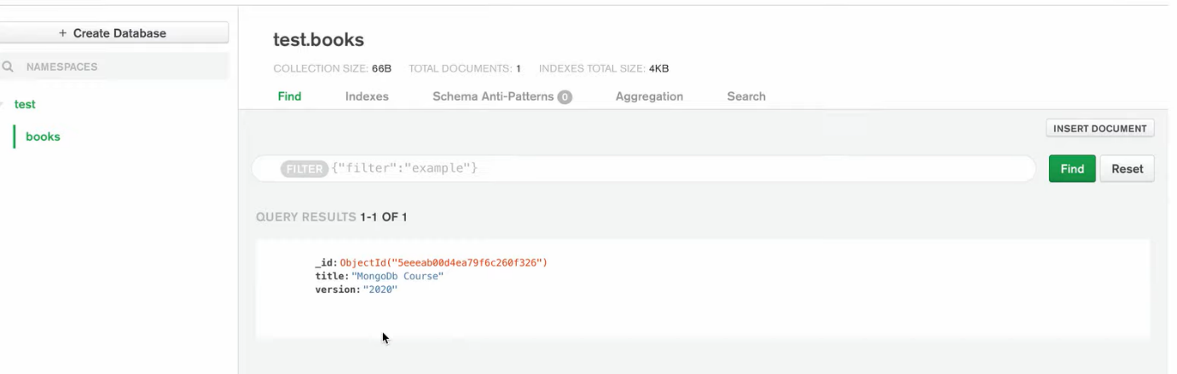

**Data modelling:-**

It organizes elements of data and standardizes how they relate to one another.

They are two types Data Modals are:

1.Embedded Data modal

2.Normalize Data modal

**1.Embedded Data modal-** In this you can have all related data in a single document.

**Ex-**

As we want to enter the details of employee in a database

({Emp id : 121

Name : ”AABCF”

Contact : { emailed :[asdd@gmail.com](mailto:asdd@gmail.com)

Mobile no : 7878787878

}

})

**2.Normalize Data modal-** In this you refer the sub documents in the original document.

**Ex-**

Emp:

{

Empid:1212122

Objid:<object1>

}

Personal details:

{

Objid:<object2>

empDocid :”object1”

Name : “DHJNK”

}

Contact:

{

Objid:<object3>

empDocid:”object1”

Mob: 90909090

}

**Datatypes:**

Data stored in BSON format “Binary encoded format of JSON.

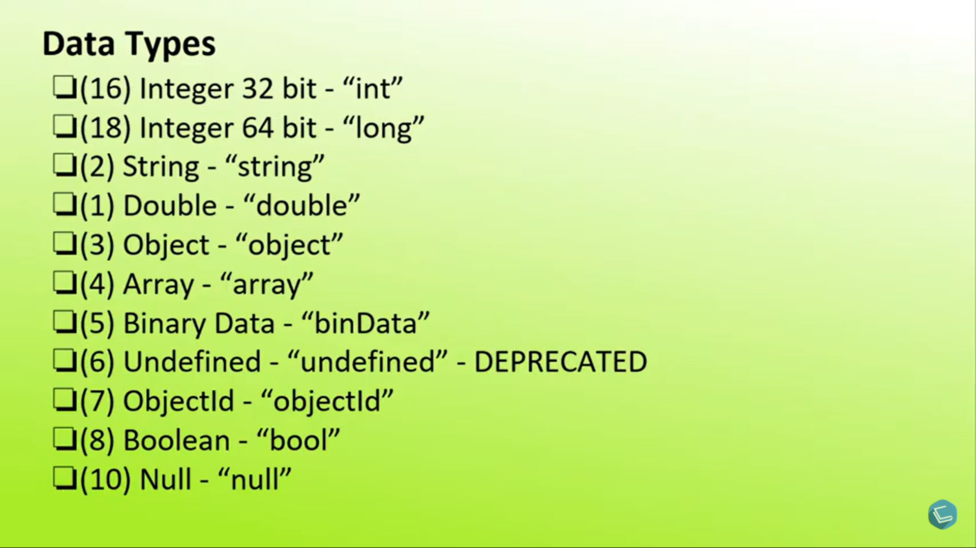

**CRUD Operations:-**

**C-**Create

**R-**Read

**U-**Update

**D-**Delete

**Create-** First we create a database by using ‘use’ command

**Ex-**

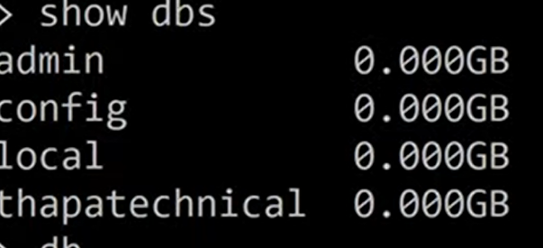

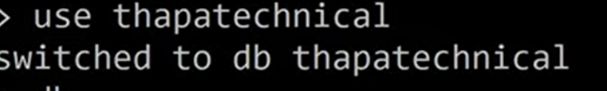

Than database was create after that we make a collection by using-

Ex-

db.createCollection(‘Harsh’)

After that we want to insert the data by using two commands-

1)Insertone

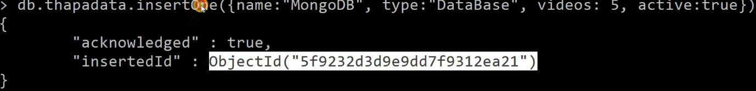

2)Insertmany

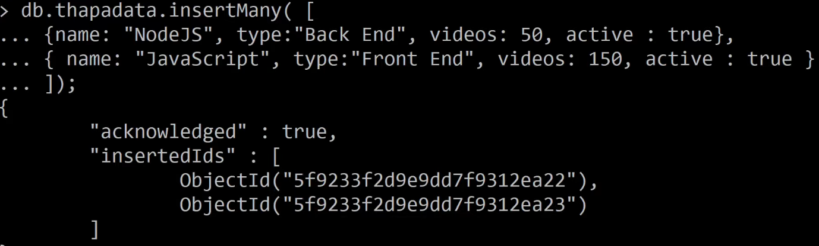

**READ-**

To find the data



To find the data whose name is MongoDb



To find a data whose name is Mongodb but only name is shown



**Update**

We want to update data whose name is Javascript to set the type cc



**Delete**

When we want delete a particular document

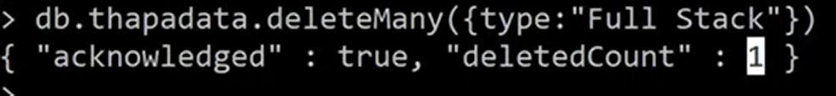

When we want to delete all document

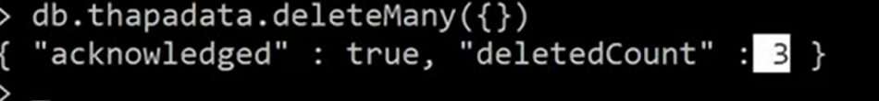

**Relations**

In this we can create a relation between data by using a uniqueId

There are some types of relations:

1)One to one relation- In this one document can relate with another document.

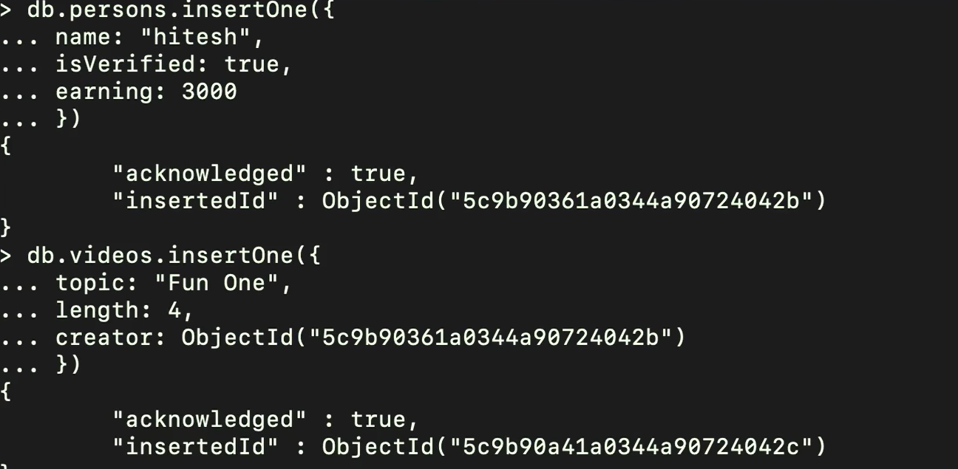

Display the results

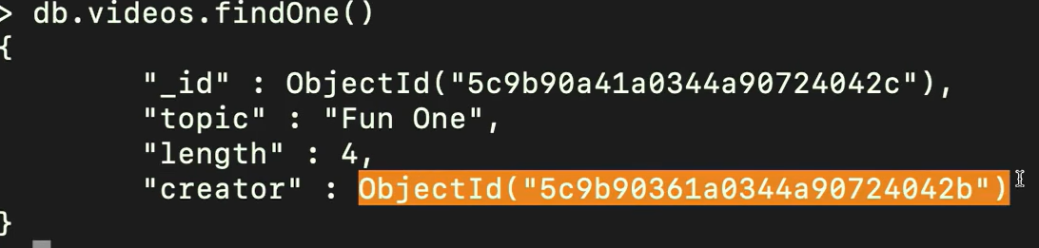

2)One to many

Create a single document

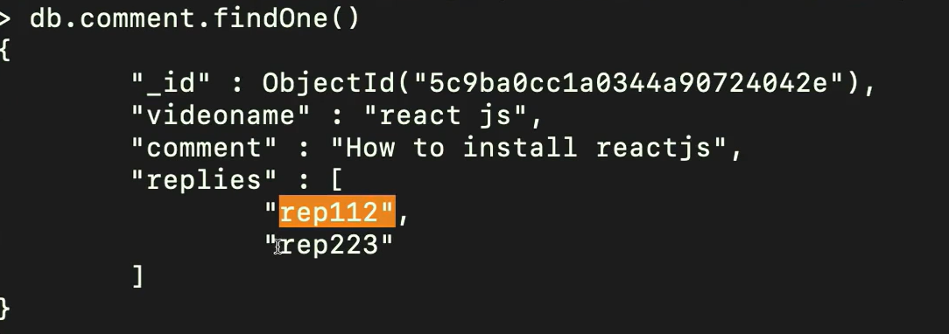

Link the document to another

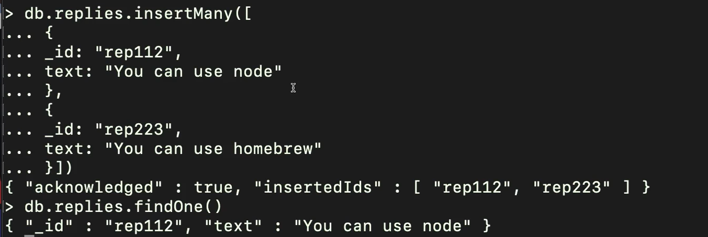

3)Many to many- In this we want to create relation between many documents by using there objectId.

Enter first data as a course

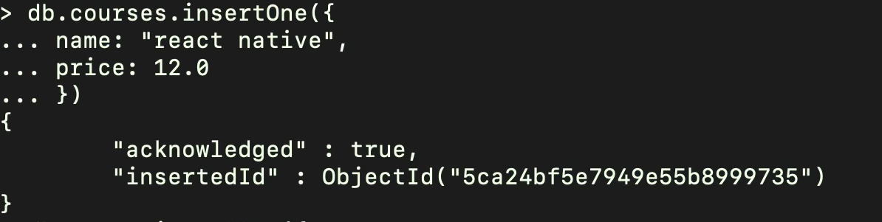

Enter the second data as a user

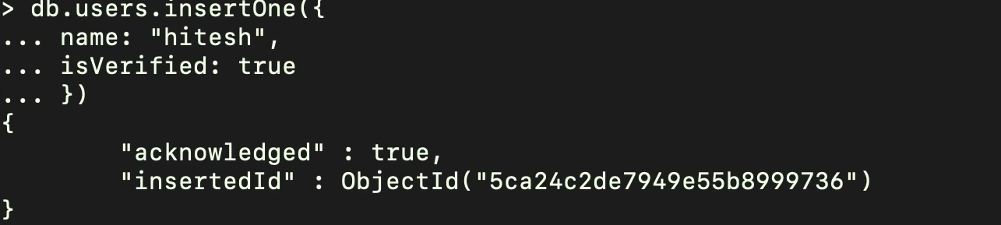

Than combine them into a single data

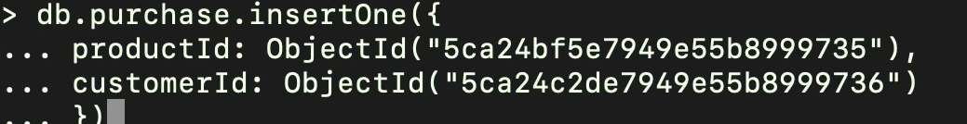

**Indexing:-** It is used to improve the query performance.

Ex-

Db.createIndex({age:1})

In this we can set a indexing in ascending order (1)or descending order(-1).

**Sharding-\***It is a horizontal scaling of database.